VALID ISBN?

Lab # 3

BY

Corey Henry

Cah835

***“On my honor, as a Mississippi State University student, I have neither given nor received unauthorized assistance on this academic work.”***

***Signature X__________________________***

CSE1284 Introduction to Computer Programming

Class Section # 1

Corey Henry  
Sep 10, 2014

Problem: Determine if the ISBN number is valid

Solution: See attached flowchart**

Sample Execution

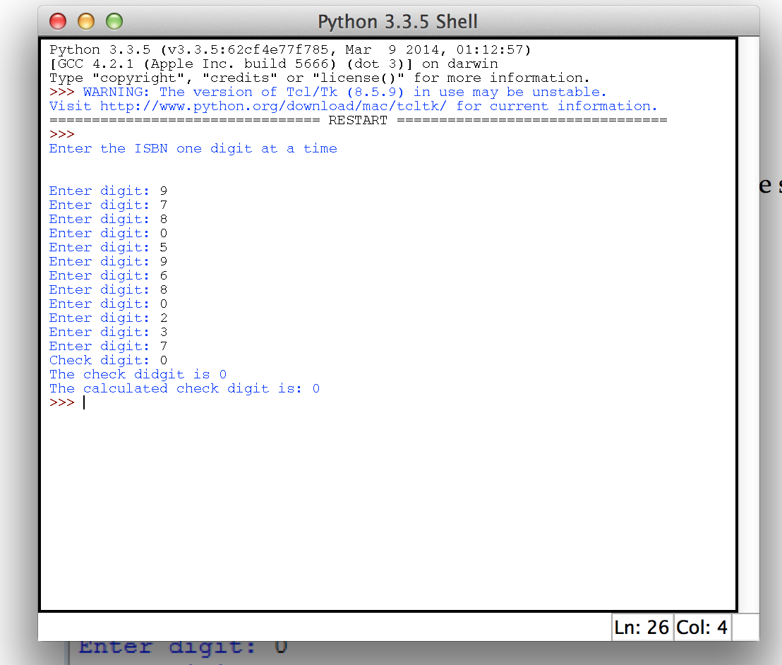

Analysis and conclusion: Lab was not very difficult, I had a issue where if the resulting check digit ended up being 0 I would end up with 10. After including and If or else statement I fixed the problem and was able to finish the program.

Code: Submitted via Mycourses.